Question 1：
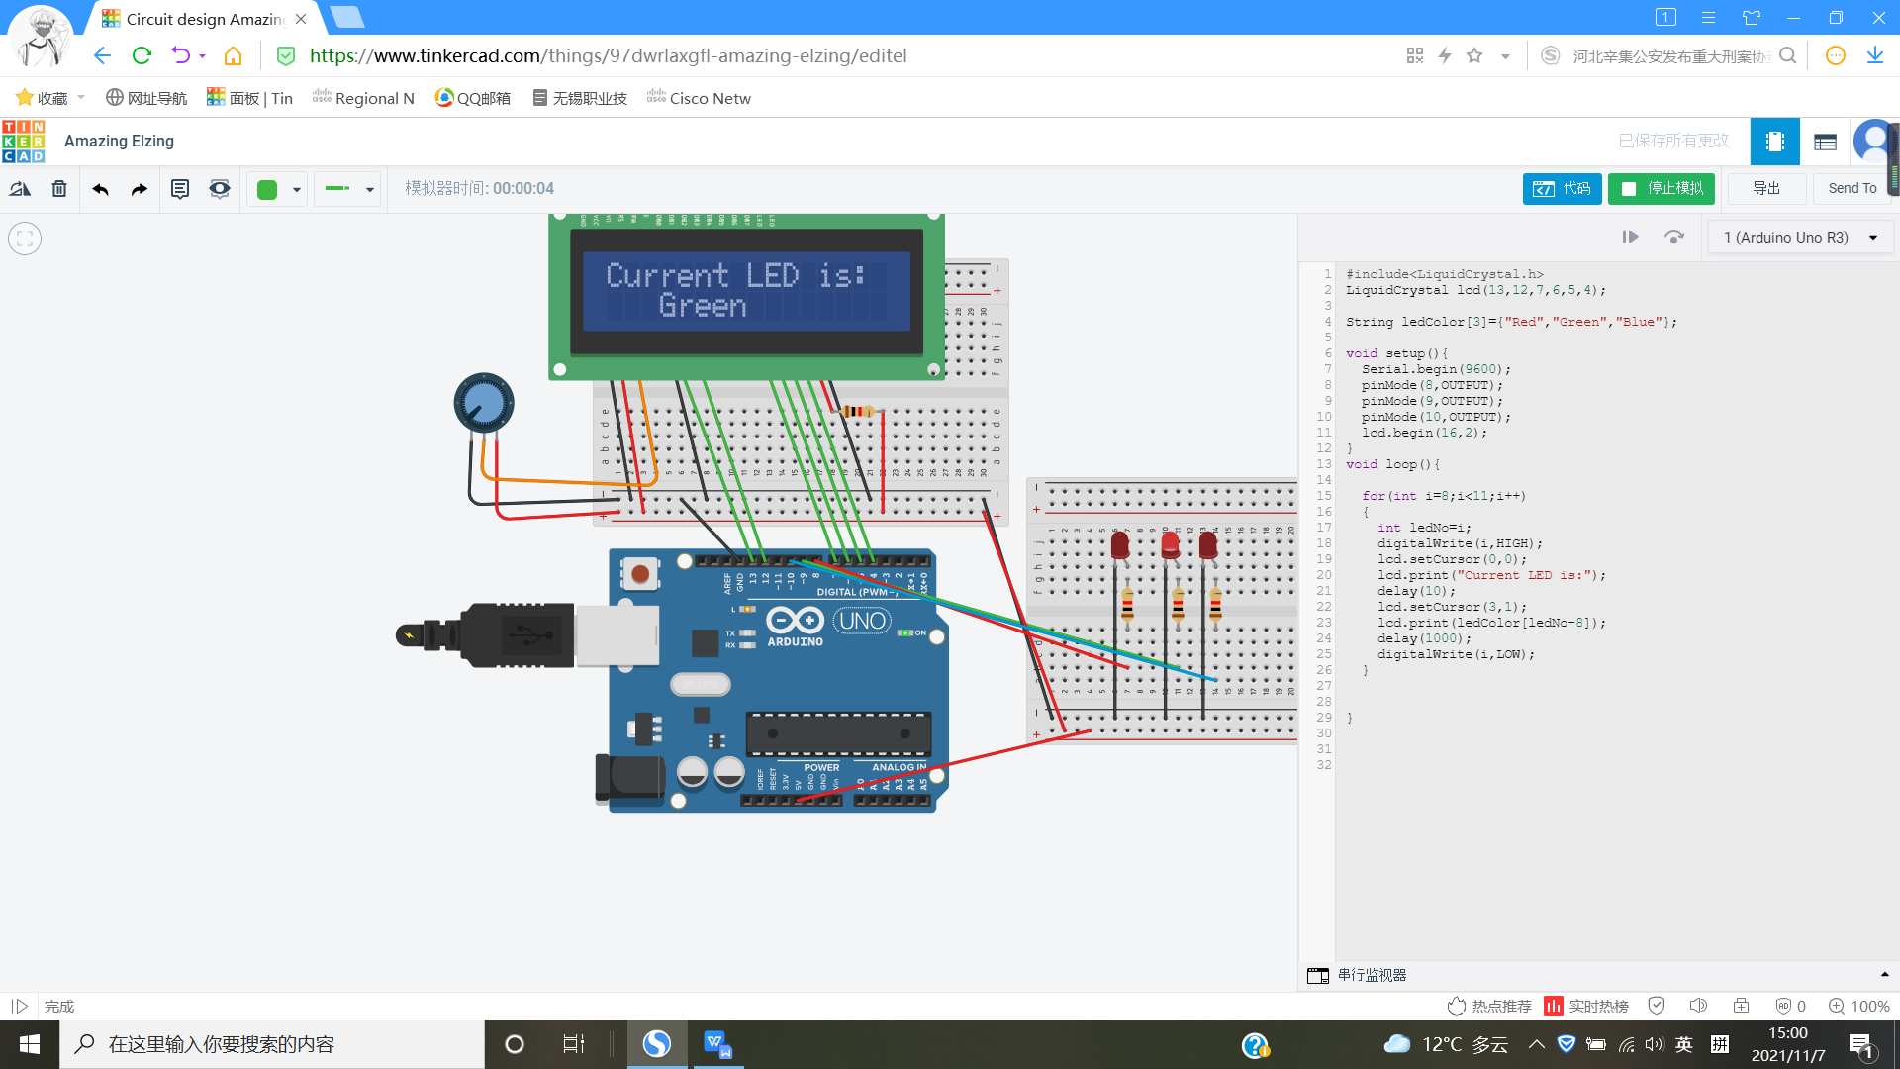

#include<LiquidCrystal.h>
LiquidCrystal lcd(13,12,7,6,5,4);

String ledColor[3]={"Red","Green","Blue"};

void setup(){
Serial.begin(9600);
pinMode(8,OUTPUT);
pinMode(9,OUTPUT);
pinMode(10,OUTPUT);
lcd.begin(16,2);
}
void loop(){

for(int i=8;i<11;i++)
{
int ledNo=i;
digitalWrite(i,HIGH);
lcd.setCursor(0,0);
lcd.print("Current LED is:");
delay(10);
lcd.setCursor(3,1);
lcd.print(ledColor[ledNo-8]);
delay(1000);
digitalWrite(i,LOW);
}

}

